**实验二 实验报告**

**（一）8-3线优先编码器的测试**

|  |  |  |  |  |  |  |  |  |  |  |  |  |  |
| --- | --- | --- | --- | --- | --- | --- | --- | --- | --- | --- | --- | --- | --- |
| EI | I0 | I1 | I2 | I3 | I4 | I5 | I6 | I7 | Y2 | Y1 | Y0 | S | E0 |
| 1 | × | × | × | × | × | × | × | × | 1 | 1 | 1 | 1 | 1 |
| 0 | 1 | 1 | 1 | 1 | 1 | 1 | 1 | 1 | 0 | 1 | 1 | 1 | 1 |
| 0 | × | × | × | × | × | × | × | 0 | 1 | 0 | 0 | 0 | 0 |
| 0 | × | × | × | × | × | × | 0 | 1 | 1 | 0 | 0 | 0 | 1 |
| 0 | × | × | × | × | × | 0 | 1 | 1 | 1 | 0 | 0 | 1 | 0 |
| 0 | × | × | × | × | 0 | 1 | 1 | 1 | 1 | 0 | 0 | 1 | 1 |
| 0 | × | × | × | 0 | 1 | 1 | 1 | 1 | 1 | 0 | 1 | 0 | 0 |
| 0 | × | × | 0 | 1 | 1 | 1 | 1 | 1 | 1 | 0 | 1 | 0 | 1 |
| 0 | × | 0 | 1 | 1 | 1 | 1 | 1 | 1 | 1 | 0 | 1 | 1 | 0 |
| 0 | 0 | 1 | 1 | 1 | 1 | 1 | 1 | 1 | 1 | 0 | 1 | 1 | 1 |

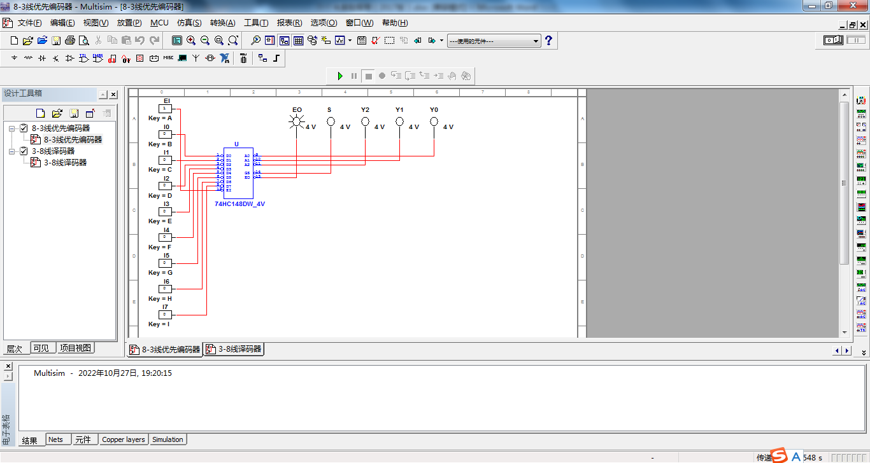

**从真值表可以看出：**

**EI只有是低电平的时候，该芯片才工作；**

**I7看做是最低位，I0看做最高位；**

**Y2，Y1，Y0遵循8421码的规律；**

**只要有输入，GS就输出低电平；**

**I7的优先级最高，I0的优先级最低，且低电平为有效输入；**

**（二）3-8线译码器的测试**

|  |  |  |  |  |  |  |  |  |  |  |  |  |
| --- | --- | --- | --- | --- | --- | --- | --- | --- | --- | --- | --- | --- |
| 使 能 | | 选 择 | | | Y0 | Y1 | Y2 | Y3 | Y4 | Y5 | Y6 | Y7 |
| S1 | S2+S3 | A2 | A1 | A0 |
| × | 1 | × | × | × | 1 | 1 | 1 | 1 | 1 | 1 | 1 | 1 |
| 0 | × | × | × | × | 1 | 1 | 1 | 1 | 1 | 1 | 1 | 1 |
| 1 | 0 | 0 | 0 | 0 | 0 | 1 | 1 | 1 | 1 | 1 | 1 | 1 |
| 1 | 0 | 0 | 0 | 1 | 1 | 0 | 1 | 1 | 1 | 1 | 1 | 1 |
| 1 | 0 | 0 | 1 | 0 | 1 | 1 | 0 | 1 | 1 | 1 | 1 | 1 |
| 1 | 0 | 0 | 1 | 1 | 1 | 1 | 1 | 0 | 1 | 1 | 1 | 1 |
| 1 | 0 | 1 | 0 | 0 | 1 | 1 | 1 | 1 | 0 | 1 | 1 | 1 |
| 1 | 0 | 1 | 0 | 1 | 1 | 1 | 1 | 1 | 1 | 0 | 1 | 1 |
| 1 | 0 | 1 | 1 | 0 | 1 | 1 | 1 | 1 | 1 | 1 | 0 | 1 |
| l | 0 | 1 | 1 | 1 | 1 | 1 | 1 | 1 | 1 | 1 | 1 | 0 |

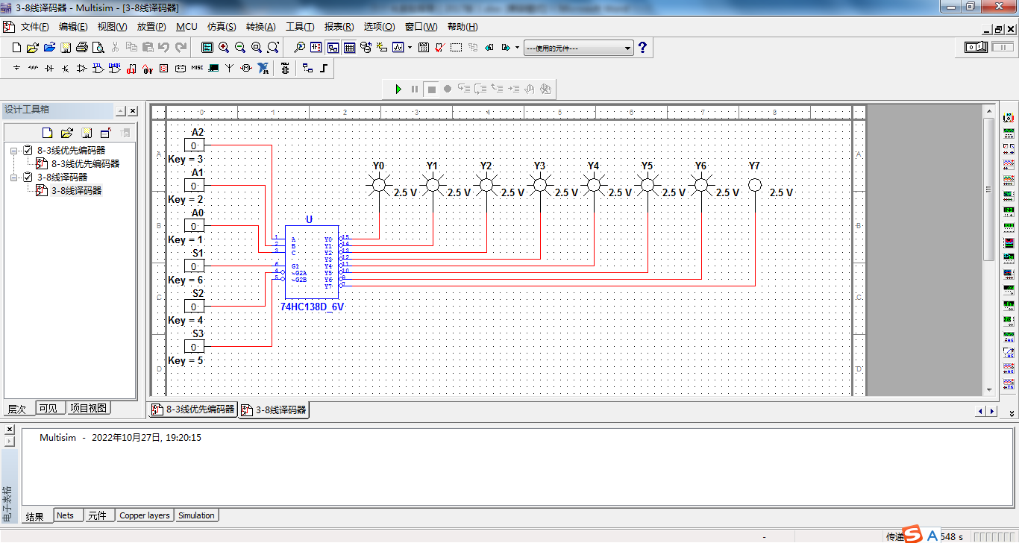

**从真值表可以看出：**

**当S1为0或者S2+S3为1时所有输出端都被封锁在高电平，**

**只有当S1为1和S2+S3为0时，该芯片正常工作。**

**（三）七段译码器的测试**

|  |  |  |  |  |  |  |  |  |  |  |
| --- | --- | --- | --- | --- | --- | --- | --- | --- | --- | --- |
| D | C | B | A | a | b | c | d | e | f | g |
| 0 | 0 | 0 | 0 | 0 | 0 | 0 | 0 | 0 | 0 | 1 |
| 0 | 0 | 0 | 1 | 1 | 0 | 0 | 1 | 1 | 1 | 1 |
| 0 | 0 | 1 | 0 | 0 | 0 | 1 | 0 | 0 | 1 | 0 |
| 0 | 0 | 1 | 1 | 0 | 0 | 0 | 0 | 1 | 1 | 0 |
| 0 | 1 | 0 | 0 | 1 | 0 | 0 | 1 | 1 | 0 | 0 |
| 0 | 1 | 0 | 1 | 0 | 1 | 0 | 0 | 1 | 0 | 0 |
| 0 | 1 | 1 | 0 | 1 | 1 | 0 | 0 | 0 | 0 | 0 |
| 0 | 1 | 1 | 1 | 0 | 0 | 0 | 1 | 1 | 1 | 1 |
| 1 | 0 | 0 | 0 | 0 | 0 | 0 | 0 | 0 | 0 | 0 |
| 1 | 0 | 0 | 1 | 0 | 0 | 0 | 1 | 1 | 0 | 0 |

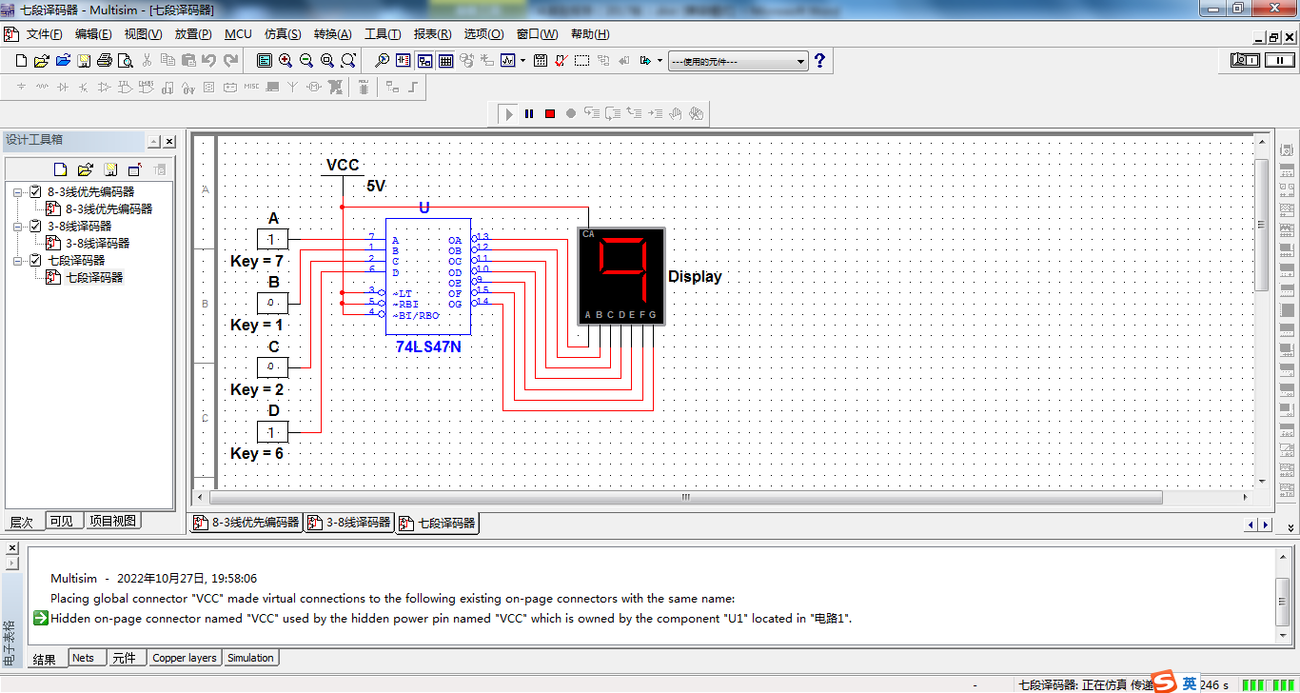

**七段数码管的CA接了一个VCC电源，使用了公共阳极，所以数码管予以显示的位置反而是低电平，用0表示。**

**（四）4选1数据选择器**

1. 4选1数据选择器的测试

|  |  |  |  |  |  |  |  |
| --- | --- | --- | --- | --- | --- | --- | --- |
| lS | A1 | A0 | 1D3 | 1D2 | 1D1 | 1D0 | 1Y |
| 1 | × | × | × | × | × | × | 0 |
| 0 | 0 | 0 | × | × | × | 0 | 0 |
| 1 | 1 |
| 0 | 0 | 1 | × | × | 0 | × | 0 |
| 1 | 1 |
| 0 | 1 | 0 | × | 0 | × | × | 0 |
| 1 | 1 |
| 0 | 1 | 1 | 0 | × | × | × | 0 |
| 1 | 1 |

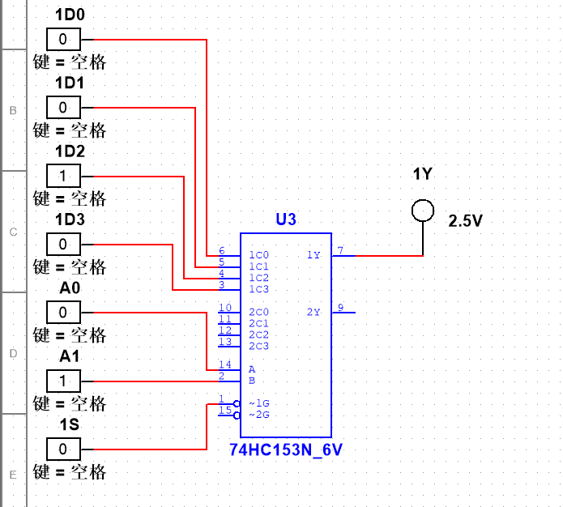

**当S1=1时，不会工作，当S1=0时开始工作。**

2. 4选1数据选择器的分析

|  |  |  |  |  |
| --- | --- | --- | --- | --- |
| A | B | C | 1Y | 2Y |
| 0 | 0 | 0 | 0 | 0 |
| 0 | 0 | 1 | 1 | 0 |
| 0 | 1 | 0 | 1 | 0 |
| 0 | 1 | 1 | 0 | 1 |
| 1 | 0 | 0 | 1 | 0 |
| 1 | 0 | 1 | 0 | 1 |
| 1 | 1 | 0 | 0 | 1 |
| 1 | 1 | 1 | 1 | 1 |

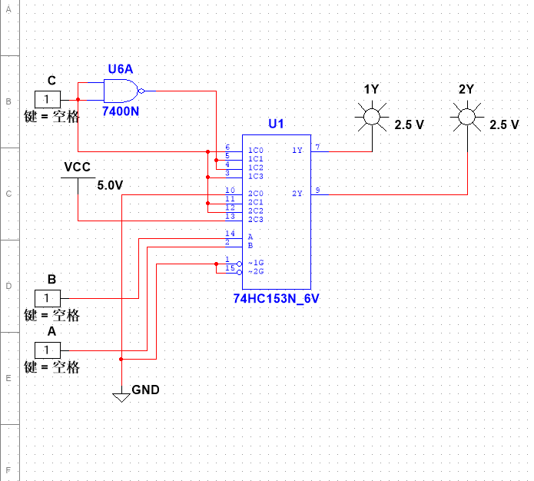

根据测试结果的数据分析，可得到输出函数1Y和2Y的逻辑表达式为：

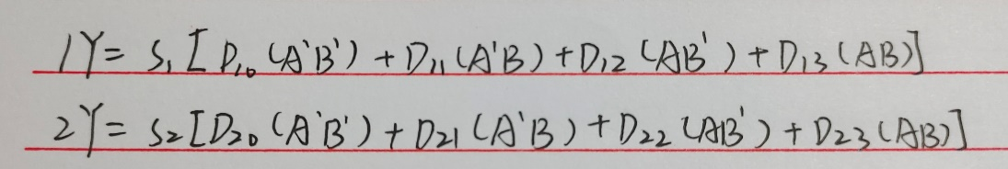

该电路的逻辑功能为：

**从多路数据中选择其中一路信号发送出去，是一个多输入、单输出的组合逻辑电路。**

**（五）8选1数据选择器**

1. 8选1数据选择器的测试

|  |  |  |  |  |  |  |  |  |  |  |  |  |  |
| --- | --- | --- | --- | --- | --- | --- | --- | --- | --- | --- | --- | --- | --- |
| S | A2 | A1 | A0 | D7 | D6 | D5 | D4 | D3 | D2 | D1 | D0 | Y | W |
| 1 | × | × | × | × | × | × | × | × | × | × | × | 0 | 1 |
| 0 | 0 | 0 | 0 | × | × | × | × | × | × | × | 0 | 0 | 1 |
| 1 | 1 | 0 |
| 0 | 0 | 0 | 1 | × | × | × | × | × | × | 0 | × | 0 | 1 |
| 1 | 1 | 0 |
| 0 | 0 | 1 | 0 | × | × | × | × | × | 0 | × | × | 0 | 1 |
| 1 | 1 | 0 |
| 0 | 0 | 1 | 1 | × | × | × | × | 0 | × | × | × | 0 | 1 |
| 1 | 1 | 0 |
| 0 | 1 | 0 | 0 | × | × | × | 0 | × | × | × | × | 0 | 1 |
| 1 | 1 | 0 |
| 0 | 1 | 0 | 1 | × | × | 0 | × | × | × | × | × | 0 | 1 |
| 1 | 1 | 0 |
| 0 | 1 | 1 | 0 | × | 0 | × | × | × | × | × | × | 0 | 1 |
| 1 | 1 | 0 |
| 0 | 1 | 1 | 1 | 0 | × | × | × | × | × | × | × | 0 | 1 |
| 1 | 1 | 0 |

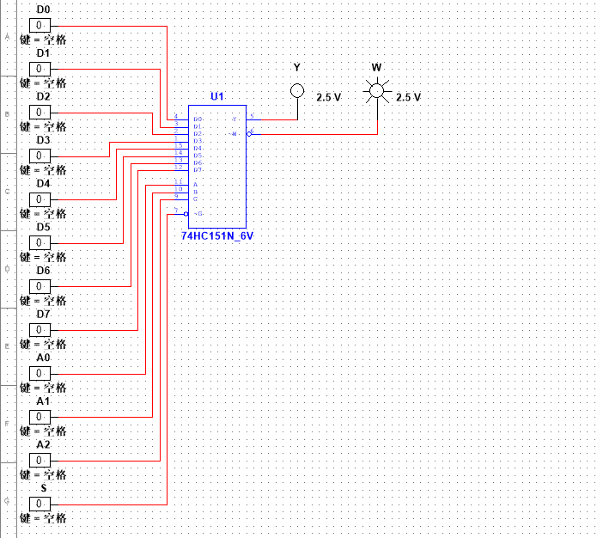

2. 8选1数据选择器的分析

|  |  |  |
| --- | --- | --- |
| D0 D1 D2 D3 D4 D5 D6 D7 | A2 A1 A0 | L0 L1 L2 L3 L4 L5 L6 L7 |
| 1111 0000 | 0 0 0 | 1 1 1 1 1 1 1 1 |
| 0 0 1 | 1 0 1 1 1 1 1 1 |
| 0 1 0 | 1 1 1 1 1 1 1 1 |
| 0 1 1 | 1 1 1 0 1 1 1 1 |
| 1 0 0 | 1 1 1 1 1 1 1 1 |
| 1 0 1 | 1 1 1 1 1 0 1 1 |
| 1 1 0 | 1 1 1 1 1 1 1 1 |
| 1 1 1 | 1 1 1 1 1 1 1 0 |
| 1010 1010 | 0 0 0 | 1 1 1 1 1 1 1 1 |
| 0 0 1 | 1 1 1 1 1 1 1 1 |
| 0 1 0 | 1 1 1 1 1 1 1 1 |
| 0 1 1 | 1 1 1 1 1 1 1 1 |
| 1 0 0 | 1 1 1 1 0 1 1 1 |
| 1 0 1 | 1 1 1 1 1 0 1 1 |
| 1 1 0 | 1 1 1 1 1 1 0 1 |
| 1 1 1 | 1 1 1 1 1 1 1 0 |

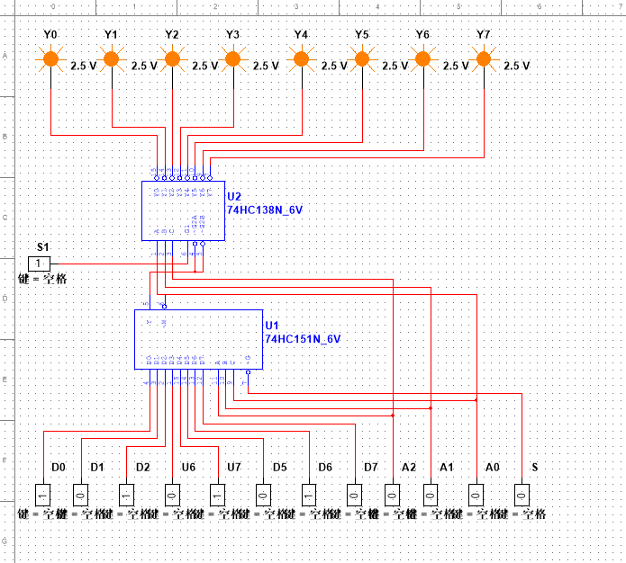

根据对测试结果的分析，该电路所完成的功能是：

**从可以根据需要从8路数据传送中选出一路电路进行信号切换，是一个多输入、单输出的组合逻辑电路。**